My Diabetes Passport:
Planning for Surgery

Referral Preoperative care Hospital admission Discharge

Name:

Proposed date of operation:

This booklet has been provided for you by the Ipswich Hospital Diabetes Team
Diabetes and Endocrine Centre Ipswich Hospital
t
n
Tel: 01473 704180
C
a
r
e
&
E
I
n
p
a
t
i
e

Safe Diabetes Care
d
u
c
a
t
i
i
a
b
e
t
e
s
D.I.C.E

Issue 7: January 2020 Review date: December 2022
o
n
D
© East Suffolk and North Essex NHS Foundation Trust, 2015-2020. All rights reserved. Not to be reproduced in whole, or in part, without the permission of the copyright owner.

Referral Preoperative care Hospital admission Discharge

Your perioperative diabetes passport
You have been given this booklet because you have diabetes and are having a planned operation.
‘Perioperative’ describes the journey you will take before, during
and after your operation.
It has been shown that patients whose diabetes is well controlled before their operation are less likely to have complications and more likely to be discharged home earlier.
The aim of this perioperative diabetes passport is to help you and the healthcare professionals looking after you ensure that you are in the best possible condition for surgery and to make sure you receive the most appropriate care during your inpatient stay.
You may have noticed that the pages in this diabetes passport are different colours.
The yellow pages are for you to fill out with information about you that will be helpful to your care.
The blue are information sheets for you to read.
The green are for your healthcare professionals to fill in.

Please bring this diabetes passport to all appointments you have with a healthcare professional, at both the hospital and at your GP surgery.
Key points
- Good control before surgery reduces complications.
- Keep this booklet with you during your inpatient stay.

Referral Preoperative care Hospital admission Discharge

My details

About you...
Name: I like to be called: Date of birth:
NHS number:
Address:

Home telephone number: Mobile number:

About your GP surgery...
Usual / Registered GP: Address:

Telephone number:

Your next of kin’s contact details...
Name: Address:

Home telephone number: Mobile number:

Referral Preoperative care Hospital admission Discharge

Type of diabetes
Type 1
Type 2
Other

Filled in by: Date:

Referral Preoperative care Hospital admission Discharge

My diabetes
Place of usual care (for example, GP / Hospital team):

Diabetes medication:
(We will have information on the medicines you normally take but please confirm your diabetic medicine.)

Medication Chart | Medication name (Insulin / Tablet) | Dose / Units
Breakfast
Lunch
Evening Meal
Bedtime

Are you normally on insulin? Yes No

What is the name of the insulin you use?

What devices do you use?
Pen and cartridge Pump
Disposable pen Needle syringe Innolet

Referral Preoperative care Hospital admission Discharge

Where are your normal injection sites?
Who normally manages your diabetes medication? (Tick all that apply.)
Self Relative Carer Dosset box

Hypos
Do you have hypos? Yes No

Approximately how many hypos a week do you have?

Do you normally get warning symptoms before you have a hypo? Yes No
What are the things that people could do to support you with your diabetes whilst you are in hospital?

Referral Preoperative care Hospital admission Discharge

Other medical history
These are the other medical conditions I have:

Swallowing difficulties: Yes No

History of heart disease / lung disease / kidney disease?
Yes No

Details:

Referral Preoperative care Hospital admission Discharge

Eating and drinking
I normally eat at the following times:

Do you have any specific dietary requirements, such as vegetarian / allergies?

Foods I dislike include:

My choices of snacks include:

You should be offered a snack before bed if you are on insulin or certain other diabetes medications, but you may also prefer to bring your own supply of snacks into hospital.
Also please bring in any treatments you may prefer to use for hypo treatment, such as jelly babies.

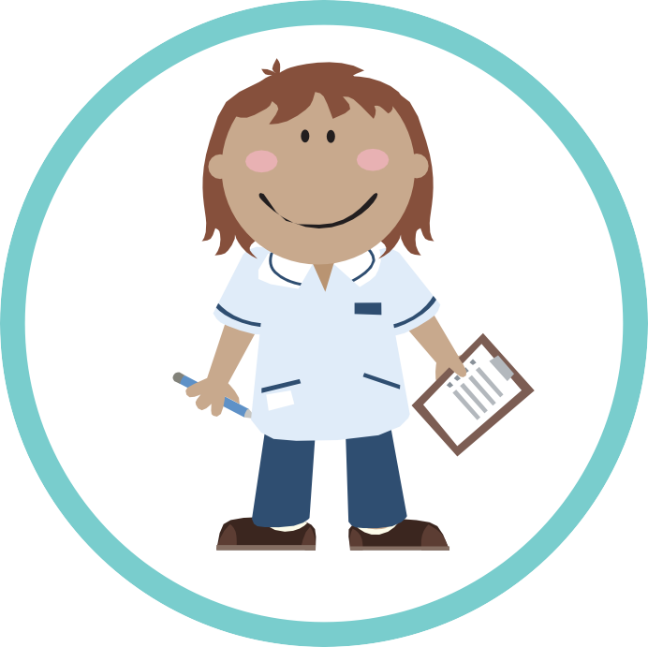
Referral
Preoperative care
Hospital admission Discharge

Preoperative care...

Referral
Preoperative care
Hospital admission Discharge

Blood glucose control
High blood glucose can increase the risk of infections and lead to less favourable outcomes following surgery. Good blood glucose control has also been shown to improve healing after surgery.
HbA1c is a blood test that gives an overall picture of your blood glucose levels over the past three months.

We recommend that your HbA1c should be 8.5% (69 mmol / mol) or less before your operation – the lower, the better.
For certain operations, a lower target HbA1c may be required. Your HbA1c wilI be tested at your pre-operative assessment and nurses will be able to advise you on the result.

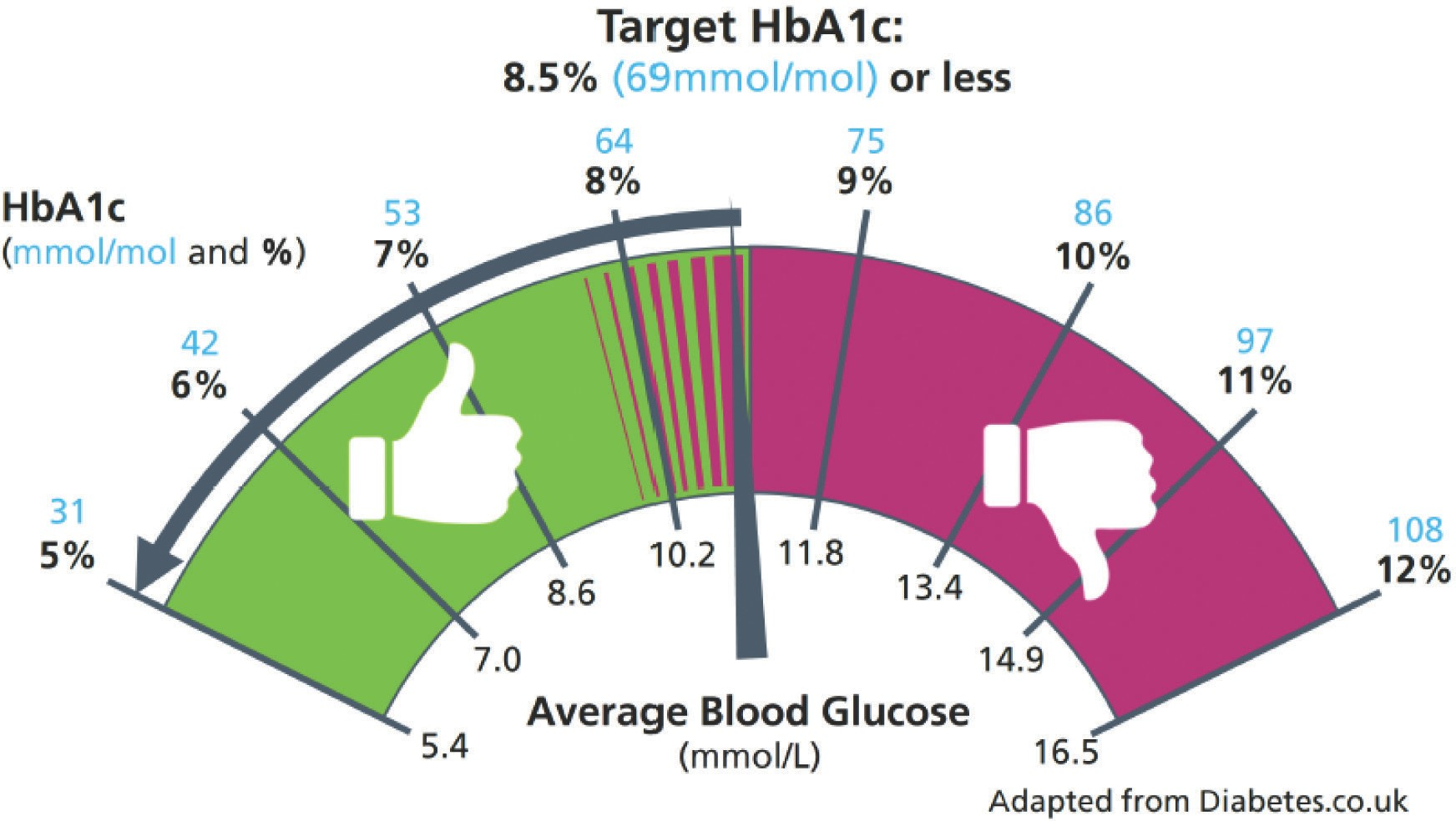

Referral
Preoperative care
Hospital admission Discharge

Body mass index = weight [kgs] ÷ (height [m])2

Date | Weight (kg) | Height (cm) | BMI

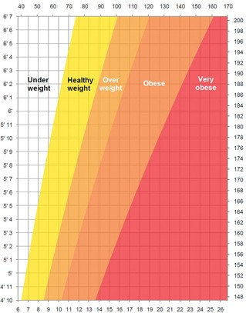
Your weight in kilograms
6’ 7
6’ 6
6’ 5
6’ 4
6’ 3
6’ 2
6’ 1
6’
5’ 11
5’ 10
5’ 9
5’ 8
5’ 7
5’ 6
5’ 5
5’ 4
5’ 3
5’ 2
5’ 1
5’
4’ 11
4’ 10
40 50 60 70 80 90 100 110 120 130 140 150 160 170
200
198
196
194
192
190
188
186
184
182
180
178
176
174
172
170
168
166
164
162
160
158
156
154
152
150
148
6 7 8 9 10 11 12 13 14 15 16 17 18 19 20 21 22 23 24 25 26
Your height in feet and inches
Your height in centimetres
Your weight in stones

Referral
Preoperative care
Hospital admission Discharge

Blood pressure readings

Date | BP reading | Taken by

190
Systolic (Top Number)
High blood pressure
Pre-high blood pressure
Ideal blood pressure
Low

180
170
160
150
140
130
120
110
100
90
80
70
40 50

60 70 80

90 100

Diastolic (Bottom Number)

Ideally your BP should be with in the green section – 120 / 80 or lower. However, for some operations a higher BP reading may be acceptable.

Referral
Preoperative care
Hospital admission Discharge

Referrals
Following on from your pre-op assessment you have been referred:
To an anaesthetist To LiveWell Suffolk Back to your GP
To the Diabetes team
Other The reasons for this referral are:

You have also been given a copy of the following management of medications before surgery leaflet(s):
Leaflet 1 – Diet-controlled diabetes Leaflet 2 – Tablet-controlled diabetes Leaflet 3 – GLP1 injections
Leaflet 4 – Insulin treated diabetes

Referral
Preoperative care
Hospital admission Discharge

What to do with your medication before surgery
Insulin treated diabetes
On the day of your surgery, from 6 am onwards, you should monitor your blood glucose every two hours prior to your arrival at hospital and bring your record with you. If you are driving, you should also check your blood glucose just before starting your car and drive only if your blood glucose is more than 5 mmol / L.
The following table will tell you what to do with your insulin.
If you are taking more than one type of insulin, please follow the instructions for each. If you are having bowel surgery the instructions above may differ. Please contact your diabetes team for further support.

Name of insulin | Day prior to surgery | Day of surgery if your operation is in the morning | Day of surgery if your operation is in the afternoon
Biphasic mixed insulins / Twice daily
Novomix 30, Humulin M3, Humalog Mix 25,  Humalog Mix 50,  Insuman Comb 25,  Insuman Comb 50 | Take your  usual dose | - Take half your usual morning dose  - Take your usual evening dose | - Take half your usual morning dose  - Take your usual evening dose
Basal Bolus
Rapid Insulins:  Actrapid, Humulin S, Insuman Rapid, Novorapid, Fiasp, Humalog, Apidra | Take your  usual doses | - Skip morning dose. *If also on long-acting, reduce your dose by 20%  - Take usual lunch dose if eating and drinking | - Take your usual morning dose. *If also on long-acting, reduce your dose by 20%  - Omit the lunchtime dose
 |  | c) Take usual evening dose  if eating and drinking.  *If also on long-acting, take your usual dose in the evening | c) Take usual evening dose  if eating and drinking.  *If also on long-acting, take your usual dose in the evening
Basal Insulins: | If taken in the morning:
Lantus, Levemir, Insulatard, Humulin I, Insuman Basal, Abasaglar, Toujeo, Tresiba | Reduce your dose by 20% | Reduce your dose by 20% | Reduce your dose by 20%
 | If taken in the evening:
 | Reduce your dose by 20% | Take your usual dose | Take your usual dose
 | If taken twice daily:
 | Reduce evening dose by 20% | Reduce your morning dose by 20% | Reduce your morning dose by 20%

Referral
Preoperative care
Hospital admission Discharge

What to do with your medication before surgery
Tablet or GLP-1 injections
The following table will tell you what to do with your diabetes tablets / injections. If you are taking more than one, please follow the instructions for each of them.

Name of tablet | If your operation is in the morning | If your operation is in the afternoon
Acarbose | Skip morning dose | Take usual morning dose with breakfast and omit lunchtime dose
Repaglinide, Nateglinide | Skip morning dose | Take usual morning dose with breakfast and omit lunchtime dose
Metformin (Sukkarto) | Take as usual unless specifically advised not to | Take as usual unless specifically advised not to
Gliclazide, Glibenclamide, Glipizide, Glimepiride, Gliquidone | Skip morning dose | Skip morning dose
Pioglitazone | Take as usual | Take as usual
Sitagliptin, Saxagliptin, Vildagliptin, Alogliptin, Linagliptin | Take as usual | Take as usual
Dapagliflozin, Canagliflozin, Empagliflozin | Skip morning dose and omit until post surgery and eating and drinking normally for 48 hours | Skip morning dose and omit until post surgery and eating and drinking normally for 48 hours
GLP-1 injections or tablets
Exenatide, Liraglutide, Exenatide SR, Lixisenatide | Take as usual | Take as usual

Referral
Preoperative care
Hospital admission Discharge

Fasting advice
Please follow the instructions on this page regarding fasting to prepare for your operation:
- If your operation is scheduled for a morning list do not eat any food after 12 midnight.
You can drink clear fluids such as black tea, black coffee , squash or water up until 06.30 am. Milk or fruit juices are not permitted.
- If your operation is scheduled for an afternoon list do not eat anything after a light breakfast which needs to be eaten before 07.00 am.
You can drink clear fluids such as black tea, black coffee, squash or water up until 11.30 am. Milk or fruit juices are not permitted.

Other specific fasting information:

If you begin to feel that you are becoming ‘hypo’ you could have a drink of squash which contains sugar

Department: Telephone contact:

Referral
Preoperative care
Hospital admission Discharge

What to do if you are sent an afternoon appointment for your operation
Many considerations determine the order of operating lists. One of the most important goals in patients with diabetes who are having surgery is to minimise the starvation / fasting time so that normal diet and normal medication can be resumed as early as possible.
- If you have type 1 diabetes it is normally recommended
that you have your surgery in the morning.
- If you are type 2 then it is not normally recommended
that you have your surgery in the evening.
If, when you receive your appointment letter, your procedure is not at the recommended time slot, please contact:

Telephone contact:

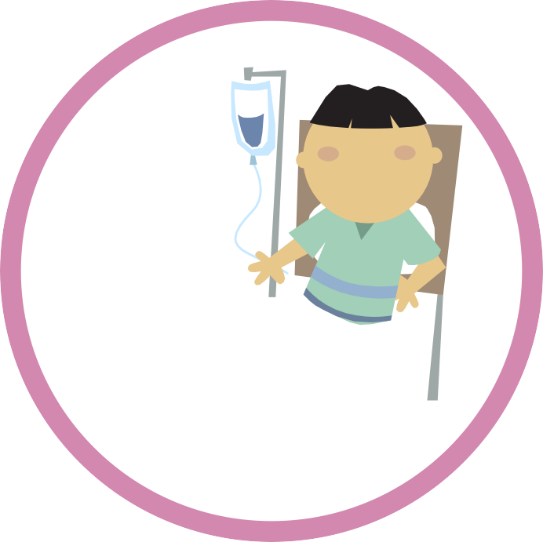
Referral Preoperative care
Hospital admission
Discharge

Hospital admission...

Referral
Preoperative care
Hospital admission
Discharge

What to bring into hospital with you
- Your diabetes medication.
- A supply of insulin needles (if you take insulin). The needles used in hospital are for use of healthcare professionals and may not be the same as you have at home.
- Any other normal medication you take.
- Blood glucose equipment (if you normally monitor your own blood glucose we encourage you to continue to do so whilst in hospital but we may also test your levels).
- Your normal hypo treatments, such as glucose drink / jelly babies.
- A few snacks.

Referral Preoperative care
Hospital admission
Discharge

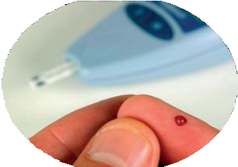
Diabetes self care

Blood glucose testing
We believe it important that you are able to manage your own diabetes in hospital if you are well enough and capable of doing so. You are allowed to do your own blood glucose tests whenever you like.
However, to promote safe care, we
will also undertake blood tests using our very accurate precision meters. These are linked by wi-fi to a computer which allows the diabetes inpatient specialist nurses to detect patients who are frequently experiencing out-of-range glucose results.

Insulin administration and dose adjustment
You may also be able to self-inject and decide on your own insulin dose but please agree this with the ward nurse so that it can be documented on your treatment record. If you are having difficulties please ask to see a member of the diabetes team. You should then be able to keep your insulin on you, but at times it maybe necessary for your insulin to be locked away.
In general you should aim for blood glucose values of between 5 mmol / L and 12 mmol / L while in hospital, except at bedtime when the target range is a little higher: between 7 mmol / L and 12 mmol / L. Don’t worry if an occasional reading is outside these ranges but if you would like advice please ask your ward nurse to contact the specialist diabetes team.

Referral
Preoperative care
Hospital admission
Discharge

Inpatient diabetes nurse team
Contact number: 01473 712233 or bleep 825.
D.I.C.E
Safe Diabetes Care
t
C
a
r
e
&
n
p
a
t
i
e
n
Whilst staying in Ipswich Hospital you may be seen by a member of the inpatient diabetes nurse team.
E
d
u
c
a
t
i
o
n
D
i
a
b
e
t
e
s
I
The team is available to provide support and management for all inpatients who have diabetes.
If you would like to speak to a member of the team during your admission to hospital, please let your ward nurse or doctor know so they can arrange this for you. Alternatively, you can contact the Diabetes team directly on the number above. The team is available Monday – Friday, 8 am – 4 pm and weekends 8 am – 12 noon.
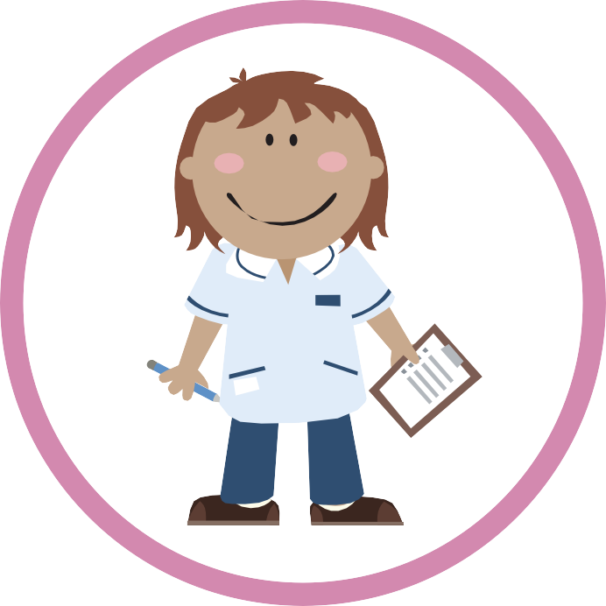

Referral Preoperative care
Hospital admission
Discharge

Inpatient diabetes specialist support team
Today you were seen by from the diabetes inpatient support team, who has given you the following advice:
Changes to your medications:

What to do next:

Further appointments:

Referral
Preoperative care
Hospital admission
Discharge

Blood glucose control in hospital
When in hospital it is not uncommon to experience changes in blood glucose control, including high glucose levels.
There are a variety of reasons for this including:
- changed medication and meal times
- altered portion sizes
- being less active
- new medications such as steroids
- periods of fasting such as before and after surgery
- the stress of being unwell
- infection.
Maintaining good control can be difficult. In hospital your targets may change for safety reasons. However, provided that your blood glucose is kept within reasonable limits, your
recovery will be quicker. For this reason, if your blood glucose is raised above 17 you may need extra treatment, including insulin, even if you normally control your diabetes by tablet or diet alone.
Please ask a member of staff on the ward if you have any queries or concerns about your blood glucose levels.

Referral Preoperative care
Hospital admission
Discharge

Hypoglycaemia (‘Hypos’)
Headachy
Grumpy Hungry Confused Sweaty Shaky
Dizzy
Unless you are treated with insulin or gliclazide (or a similar tablet from the same class) or given either of these treatments for the first time in hospital this section should not be relevant to you.
Hypoglycaemia, also known as a ‘hypo’ is
when your blood sugar (glucose) level falls too low. Any blood glucose below 4.0 mmol / L should be treated.
Sadly it is not unusual for people with diabetes treated with insulin or gliclazide to become hypoglycaemic in hospital. There are many reasons for this, including: changes in people’s daily routine, in particular eating times in hospital; and interactions between insulin and necessary medications. At Ipswich Hospital we will do our best to prevent you becoming hypoglycaemic during your inpatient stay and this is partly why we have produced this booklet.
A ‘hypo’ can occur very quickly and, if severe, it can give rise to confusion or impaired consciousness. However, in most people treatment of early symptoms will prevent severe hypoglycaemia. Be on the lookout for the following early symptoms. They may differ from person to person but include:

Blurred vision, excessive sweating, anxiety or agitation, tingling in mouth or fingers, a fast or heavy heartbeat, odd behaviour (normally recognised by others), sudden difficulty with concentration, and slurred speech.
If you experience any of the above symptoms notify a member of staff as soon as possible so that your blood sugar can be tested and, if it is low, preventative treatment can be given.

Referral
Preoperative care
Hospital admission
Discharge

Preventing night time hypos in hospital

Bedtime snack
To reduce the frequency of overnight hypoglycaemia, those treated with insulin or gliclazide will be prescribed and offered a snack before bed. Although a bed-time snack may not be your usual practice we would recommend this during your stay.

Medication adjustment
For some people we may reduce their basal or evening insulin dose and, again, for some people on gliclazide the evening dose may be reduced.
If you are adjusting your own insulin doses in hospital please bear in mind the different circumstances of being in hospital and adjust your insulin accordingly. The first priority is to avoid hypoglycaemia, but it is also important to avoid excessively high blood glucose levels.

Referral Preoperative care
Hospital admission
Discharge

How will my hypo be treated in hospital?
If you experience a hypo in hospital you will be treated with a drink of glucose powder dissolved in water. However, many patients prefer to bring in their own hypo treatments. These could be:
- 150 – 200 ml of concentrated orange juice
- 4 – 5 GlucoTabs® or 5 – 6 Dextrose® tablets
- 4 jelly babies.

If you have a hypo, treat it with some rapid-acting carbohydrate as above, let the ward sister know and test your blood glucose 10 – 15 minutes later. If it is still below 4.0 mmol / L, you should repeat the rapid-acting carbohydrate.
Don’t forget you should also follow this treatment with a more long-acting source of carbohydrate such as a banana, cereal bar or sandwich to prevent hypoglycaemia recurring several hours later.
If you are experiencing regular hypos whilst in hospital please ask your staff nurse to refer you to the specialist diabetes team.

Referral
Preoperative care
Hospital admission
Discharge

Eating for safe glucose control in hospital
Three key messages for patients, relatives, medical, nursing and catering staff.
When you are able to eat and drink normally food choice and meal size must not be restricted.
Hypoglycaemia in hospital is very common and must be prevented. For this reason food choices shouId not be restricted.

People with diabetes should eat what they eat at home.
The size of the meal should be as close to that eaten at home even if this is not what healthcare professionals would consider the ideal diabetes diet. This is how the patient normally manages so restricting their food without adjusting
their treatment will result in hypoglycaemia. The Diabetes team are there to help with adjusting medications during admission if required.

Bedtime snacks are to be encouraged
Because of the longer gaps between meals than occurs at home, snacks are available between meals for those receiving insulin or treated with gliclazide. This is especially so at bedtime as the evening meal is early in hospital there can be up to 15 hours before breakfast!

Referral Preoperative care
Hospital admission
Discharge

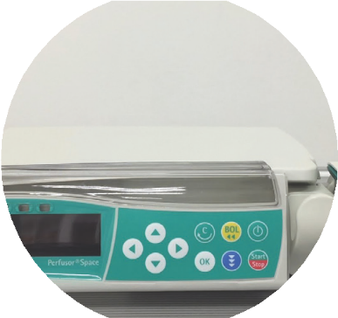
IV infusions

What is an intravenous (IV) insulin infusion?
This is a way of giving insulin directly into the bloodstream in order
to establish and maintain good control of your blood glucose. This is usually achieved using a pump which drives a syringe of insulin
connected to a small cannula (slim plastic tube) inserted into a vein in the arm. Insulin acts very rapidly when given directly into the bloodstream. By varying the rate of the insulin infusion very good diabetes control can be achieved when linked to hourly or two-hourly finger-stick blood glucose measurements.
We realise this will result in a disturbed night but it is important to have these regular blood glucose checks for the infusion to be used safely. The insulin infusion will be accompanied by a drip containing a glucose solution to keep you fed. If you are on a background (also called basal) insulin, this will usually
be continued while you are on the insulin infusion but other insulins will be stopped.

Who will require an insulin IV infusion?
If you will not be eating or drinking for a prolonged period, for example if you are having a major operation or if you become too ill to eat or drink sufficiently, then an intravenous insulin infusion is the best way to maintain good diabetes control.

How long will I be on the insulin IV infusion?
As soon as you are able to eat and drink normally the infusion should be discontinued – if not, ask why not. The sooner you are back on your usual treatment the better.

Referral
Preoperative care
Hospital admission
Discharge

What to do if the insulin IV infusion or glucose drip stops?
If the insulin infusion is stopped, the blood glucose can rise very rapidly; this is one reason why frequent blood glucose tests are required. The infusion may stop because it becomes accidently disconnected, is switched off and not switched back on again (for example when you are having a scan), or if the
cannula becomes blocked or displaced. If you notice any of these occurring, let your nurse know straight away so that it can be immediately restarted.
If the glucose drip stops then your blood glucose could drop too low causing hypoglycaemia. Therefore if you notice a problem with the glucose drip again, let your nurse know straight away so that it can be immediately restarted.

Is there anything I should know about restarting my usual treatment?
If you are on tablets these will be restarted.
If you are already on insulin it is important that the infusion is continued for the first 30 – 60 minutes after your first insulin injection. This is because after the infusion is stopped, there will rapidly be no insulin in your system; 30 – 60 minutes gives
enough time for the subcutaneously injected insulin to get into the bloodstream from the injection site. If your background insulin has not been continued while you are on the insulin infusion, this must be given before the infusion is stopped.
Switching back to the subcutaneous insulin should ideally be at a meal time, after short-acting insulin or mixed insulin has been given. This switch should not occur at bedtime when there is less observation by staff.

Referral
Preoperative care
Hospital admission
Discharge

Self-management of your insulin pump (continuous subcutaneous insulin infusion [CSII]) during your hospital admission
Insulin pumps may be used by people with type 1 diabetes to optimise blood glucose control. Pump users undergo detailed education and training in the use of the pump by the diabetes specialist team and are very familiar with self-management even during illness.
Insulin pumps use rapid- or short-acting insulin which is infused continuously subcutaneously at a pre-programmed rate set by the patient, often with the advice of the diabetes specialist team. Bolus doses are then taken for each meal. If the pump is discontinued for any reason without an alternative provision of insulin, diabetic ketoacidosis is likely to develop within a short space of time because there is no reservoir of long-acting insulin.
For this reason an insulin pump should never be discontinued without immediate substitution of rapid-acting insulin via an alternative administration route.
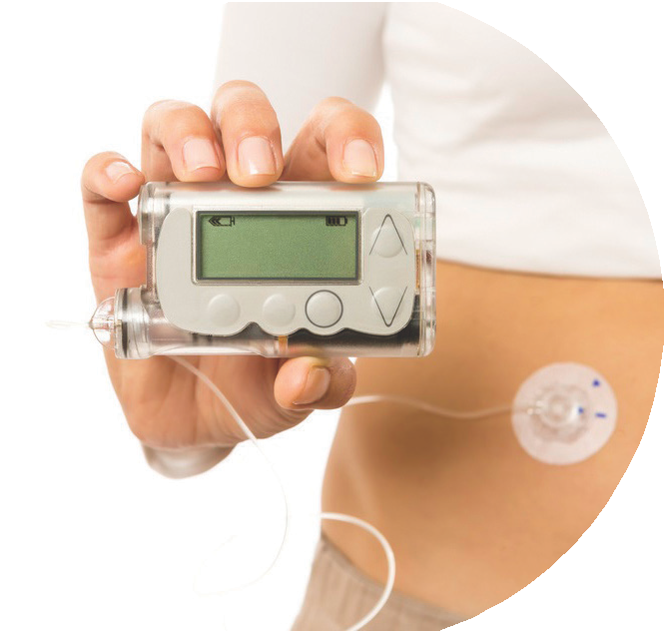

Referral
Preoperative care
Hospital admission
Discharge

Managing your pump for procedures requiring a short period of starvation

General principles
- Continuous infusion of subcutaneous insulin via a pump is designed to maintain a stable blood glucose level during the fasting state.
- You should be allowed to self-manage if you are well enough to do so. If the procedure requires you to be nil by mouth for a limited period (no more than one missed meal) you should still be able to manage your diabetes with a pump.
- However, if you are unable to self-manage because of your illness the pump will be discontinued and a variable rate intravenous insulin infusion (see section on variable rate intravenous insulin infusion) will be started immediately.
- The diabetes specialist team should be notified of all patients in hospital receiving subcutaneous insulin pump treatment, with the exception of day surgery patients. If you are on a pump, please ask to speak to a member of the diabetes team.
- If your insulin pump is discontinued it should be stored safely until you are ready to go back on the pump. Please inform the nursing team where it is stored as this should be documented.
- When you restart your insulin pump, the intravenous insulin infusion should not be discontinued until a mealtime bolus dose of insulin has been given via the pump.

Referral Preoperative care
Hospital admission
Discharge

Foot champions to protect your feet
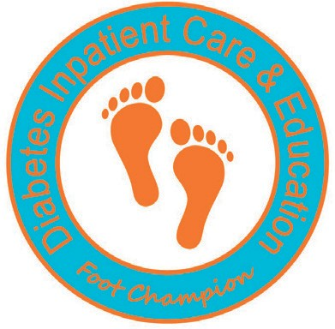
Some people with diabetes, when in hospital, are at high risk of developing sores and pressure ulcers on their feet and particularly on their heels. These can be prevented
by identifying those at risk and providing preventative foot care. At Ipswich Hospital we have a successful prevention programme
that we wish to make you aware of. Each ward has a foot champion who leads this.
You should expect to have your feet examined when you are admitted, to determine whether you are at increased risk of developing foot problems in hospital. Your nurse or healthcare assistant will undertake a very simple examination consisting of a visual foot inspection and a test of your ability to feel touch on the tips of your toes. This is called the Ipswich Touch Test. If
you have not had your feet examined, please remind the nursing staff or ask to speak to the foot champion.
You will also have your heels inspected daily to detect any early skin changes which, if addressed, can prevent the development of a heel ulcer. If you are found to be at increased risk, your feet will be elevated off the mattress to reduce pressure on your heels and you will have your feet moisturised twice a day.
Ask the nurse what he or she has found, and have a look at the Diabetes DICE Chart at the end of your bed to see that this has been documented as well as your daily heel checks.

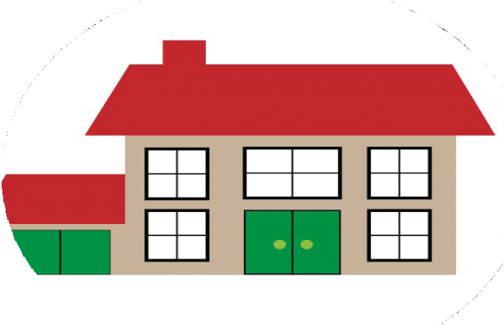
Referral Preoperative care Hospital admission Discharge

Discharge...

Referral Preoperative care Hospital admission Discharge

Sick day rules for people with diabetes

What should I do if I am unwell after my operation?
- NEVER stop taking your insulin – illness usually increases your body’s need for insulin.
- If you are vomiting, have diarrhoea or become dehydrated STOP taking metformin and SGLT2 inhibitors (dapagliflozin, canagliflozin and empagliflozin, ertugliflozin).
- TEST your blood sugars at least four times a day, if you have the equipment to do so.

If you are unable to test your blood sugar you should inform your GP that you are unwell and ask that your blood sugar be checked.
- DRINK at least 100 ml of water / sugar free fluid every hour – at least 2.5 litres a day.
- EAT as normally as you can. If you cannot eat or if you have a smaller appetite than normal, replace solid food during illness with one of the following:
  - 2 cups of milk
  - 200 ml carton of fruit juice
  - 150 – 200 ml of non-diet fizzy drink
  - 1 scoop of ice cream.
- Even if you are eating less than usual, being unwell usually makes your blood glucose rise.
- Symptoms of high blood glucose include:
  - thirst
  - passing more urine than usual
  - tiredness.
Not all illnesses have this effect and in some patients rather than rising the blood glucose level may fall when they are not eating. In this circumstance patients on gliclazide / glimepiride tablets or insulin may need to reduce their dose of diabetes medication.

Referral
Preoperative care
Hospital admission Discharge

Extra instructions for people with Type 1 diabetes
- If you are unwell and have a high blood glucose
(12 mmol / L) you should follow the ‘sick day rules’ overleaf
– they are also available online at trend-uk.org/wp- content/uploads/2018/03/A5_T1Illness_TREND_FINAL.pdf
- The golden rule is to NEVER stop insulin even if you are not eating.
- You should test regularly to track the changes in blood sugar.
- TEST your urine or blood for KETONES every two hours.
- You will need more insulin if your urine KETONES are ++2 or +++3 (or for those testing with a blood ketone meter, the level is 1.5 mmol / L or more). In this case contact your diabetes care provider.

When should I call my diabetes care provider or GP?
- If you have continuous diarrhoea and vomiting and / or a high fever.
- If you are UNABLE to keep food down for four hours or more.
- If you become DROWSY and BREATHLESS.
- HIGH blood glucose levels with symptoms of illness (if above 15 mmol / L you may need more insulin).
OUTSIDE NORMAL WORKING HOURS consult your local out-of- hours service or go to your local hospital’s A&E department.

Referral Preoperative care Hospital admission Discharge

Discharge checklist (for your information)
These pages contain an example of what should be reviewed before you leave hospital. Have a look to see if anything has been overlooked.

ALL RED BOXES MUST BE TICKED –
OTHERWISE UNSAFE DISCHARGE – RISK OF READMISSION

INSULIN AND / OR GLICLAZIDE TREATED PATIENTS
Hypoglycaemia avoidance
Confirm that the patient / family member / carer has been informed of the potential for hypoglycaemia
Confirm that the patient / family member / carer knows how to recognise and treat hypoglycaemia (give patient leaflet on ‘hypoglycaemia’ if necessary)
Confirm that the patient has access at home to usual hypoglycaemic treatments (eg fruit juice)

INSULIN TREATED PATIENTS
Insulin administration
Confirm that the patient is competent at injecting or, if not,
arrangements are in place for community (district) nurse / carer to administer
Insulin dose and timing
Confirm that the patient / family member / carer has written
instructions on insulin doses and correct timings
Treatment supplies
Confirm the supplies listed below have been provided

All patients on insulin Patients new-to-insulin therapy therapy: must also be provided with:
Vials Blood glucose meter
Syringe Insulin passport
Preloaded pen Blood glucose strips
Needles Sick Day Rules leaflet
Pen device Lancets
Insulin passport Sharps box
Cartridges Monitoring diary
Ô

Referral Preoperative care Hospital admission Discharge

PATIENTS WITH DIABETIC FOOT DISEASE
Confirm diabetic foot team are aware of discharge

Confirm patient has been informed if antibiotics need to be re-prescribed

Confirm a referral to practice nurse / community team for dressings has been made

Confirm 3 days’ supply of dressings have been given

Confirm Foot Clinic follow-up appointment (extension 6912) has been arranged

ALL PATIENTS WITH DIABETES – FOLLOW-UP ARRANGEMENTS AS APPROPRIATE TO BE MADE AS BELOW
GP (Request on electronic discharge summary) wks / mths Diabetes Centre (Telephone extension 6180 and
request on electronic discharge summary)
Community nurse
(Refer electronically and / or by telephone) Diabetes Foot Clinic (Telephone extension 6912 and request on electronic discharge summary)

Assessed by:

Signature: Name (PRINT): Designation: Date: / / Time: :

Referral Preoperative care Hospital admission Discharge

Discharge summary
Please insert a copy of the patient’s discharge summary.

Please use this space to jot down any questions you may want to ask during the ward round...

